**Hubs and Authorities:**

This document will look at another way to find central nodes in the network. This method was also developed to find relevant websites given a query e.g. Google search.

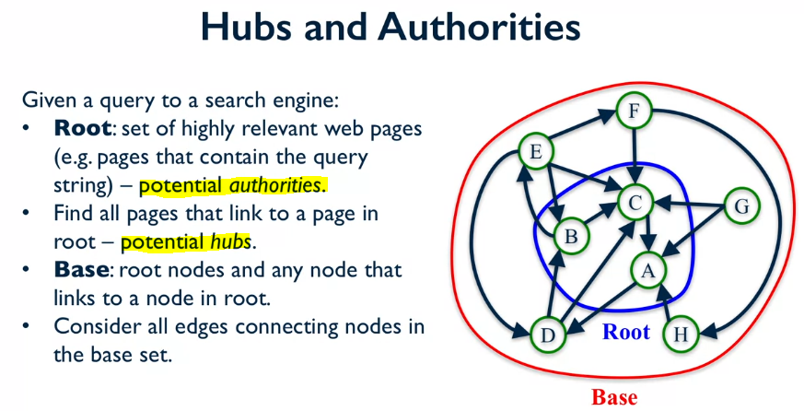

The **HITS algorithm** works in a similar way to the PageRank method, but we keep track for two variables **hubs and authorities**.

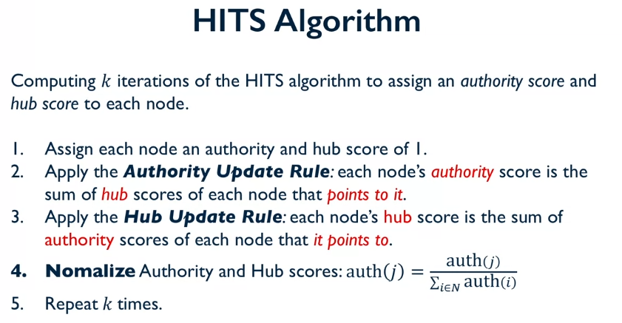

**Example:** k = 2, we set the initial scores = 1. For k=1: The authority score is the number of in connections to the node. The hub scores are just the out connections of the node. We then divide by the sum of the out and in connections respectively, in connections for the authorities and out connections for the hubs.

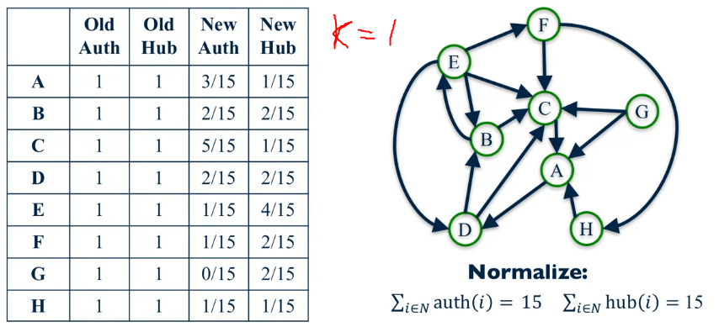

For k = 2: the new authority is then calculated from the sum of the old hubs.

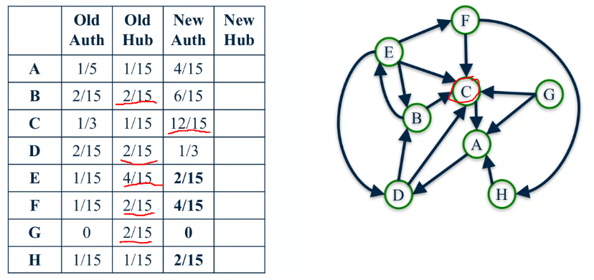

For k = 2: the new hub is then calculated from the sum of the old authorities.

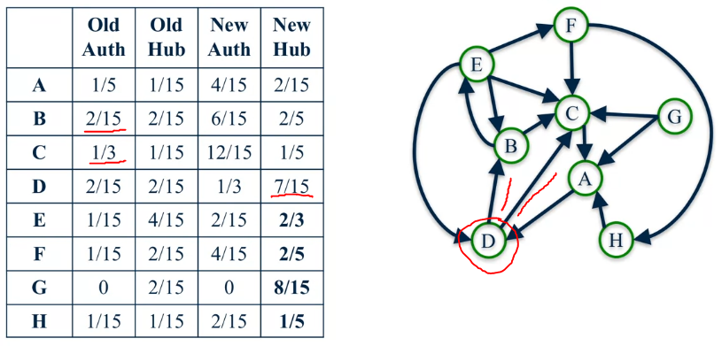

From the normalized authority and hubs we then calculate the new auth and hub by dividing them by these sums:

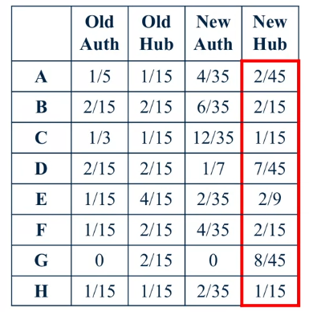

Will the scores converge, or become unstable?

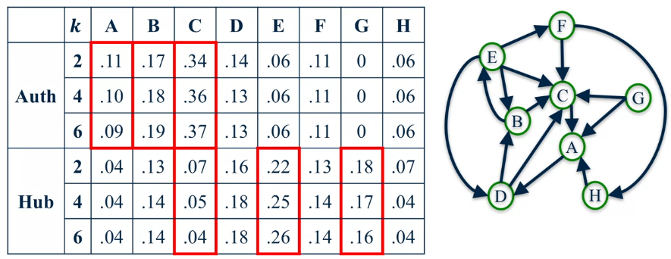

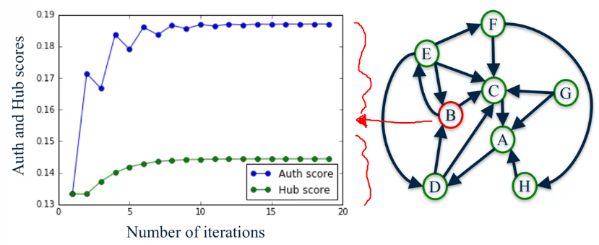

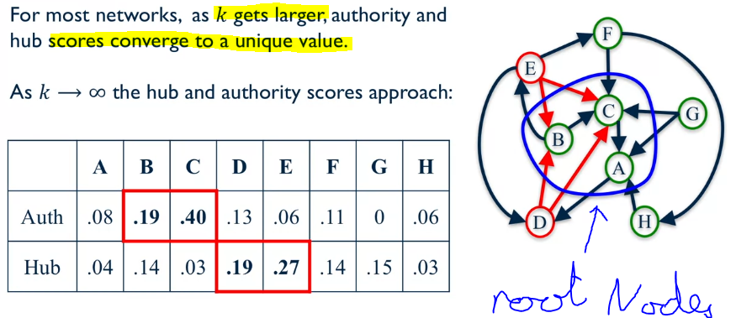

We can see that B and C have the highest Authority scores, and we can also see that these where chosen to be our root nodes. Then the biggest hubs (the nodes pointing at nodes that are relevant) D and E have the highest Hub score, and they point directly to the two most important nodes.

